Enhanced PID (PIDE)
The Enhanced PID (PIDE) instruction provides enhanced capabilities over the standard PID instruction. The instruction uses the velocity form of the PID algorithm. The gain terms are applied to the change in the value of error or PV, not the value of error or PV.
Available Languages
Function Block & ST ONLY
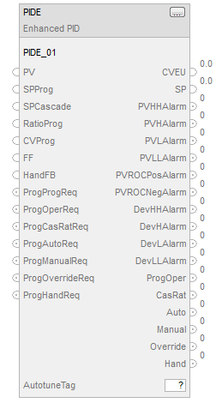
Structured Text
PIDE(PIDE_tag);
Input Parameter | Data Type | Description
EnableIn | BOOL | Enable input. If false, the instruction does not execute and  outputs are not updated. Default is true.
PV | REAL | Scaled process variable input. This value is typically read from  an analog input module. Valid = any float. Default = 0.0
PVFault | BOOL | PV bad health indicator. If PV is read from an analog input, then  PVFault is normally controlled by the analog input fault status.  When PVFault is true, it indicates the input signal has an error.  Default is false = "good health"
PVEUMax | REAL | Maximum scaled value for PV. The value of PV and SP which  corresponds to 100 percent span of the Process Variable.  Valid = PVEUMin < PVEUMax maximum positive float.  Default = 100.0
PVEUMin | REAL | Minimum scaled value for PV. The value of PV and SP which  corresponds to 0 percent span of the Process Variable.  Valid = maximum negative float PVEUMin < PVEUMax  Default = 0.0
SPProg | REAL | SP program value, scaled in PV units. SP is set to this value  when in Program control and not Cascade/Ratio mode. If the  value of SPProg < SPLLimit or > SPHLimit, the instruction sets  the appropriate bit in Status and limits the value used for SP.  Valid = SPLLimit to SPHLimit  Default = 0.0
SPOper | REAL | SP operator value, scaled in PV units. SP is set to this value  when in Operator control and not Cascade/Ratio mode. If the  value of SPOper < SPLLimit or > SPHLimit, the instruction sets  the appropriate bit in Status and limits the value used for SP.  Valid = SPLLimit to SPHLimit  Default = 0.0
SPCascade | REAL | SP Cascade value, scaled in PV units. If CascadeRatio is true  and UseRatio is false, then SP = SPCascade. This is typically the  CVEU of a primary loop. If CascadeRatio and UseRatio are true,  then SP = (SPCascade x Ratio). If the value of SPCascade < SPLLimit  or > SPHLimit, set the appropriate bit in Status and limit the value used for  SP. Valid = SPLLimit to SPHLimit Default = 0.0
SPHLimit | REAL | SP high limit value, scaled in PV units. If SPHLimit > PVEUMax, the  instruction sets the appropriate bit in Status.  Valid = SPLLimit to PVEUMax  Default = 100.0
SPLLimit | REAL | SP low limit value, scaled in PV units. If SPLLimit < PVEUMin,  the instruction sets the appropriate bit in Status. If SPHLimit < SPLLimit,  the instruction sets the appropriate bit in Status and limits SP using  the value of SPLLimit. Valid = PVEUMin to SPHLimit. Default = 0.0
UseRatio | BOOL | Allow ratio control permissive. Set to true to enable ratio control when  in Cascade/Ratio mode. Default is false.
RatioProg | REAL | Ratio program multiplier. Ratio and RatioOper are set equal to this  value when in Program control. If RatioProg < RatioLLimit or > RatioHLimit,  the instruction sets the appropriate bit in Status and limits the value used  for Ratio. Valid = RatioLLimit to RatioHLimit. Default = 1.0
RatioOper | REAL | Ratio operator multiplier. Ratio is set equal to this value when in Operator  control. If RatioOper < RatioLLimit or > RatioHLimit, the instruction sets  the appropriate bit in Status and limits the value used for Ratio.  Valid = RatioLLimit to RatioHLimit. Default = 1.0
RatioHLimit | REAL | Ratio high limit value. Limits the value of Ratio obtained from RatioProg  or RatioOper. If RatioHLimit < RatioLLimit, the instruction sets the  appropriate bit in Status and limits Ratio using the value of RatioLLimit.  Valid = RatioLLimit to maximum positive float, Default = 1.0
RatioLLimit | REAL | Ratio low limit value. Limits the value of Ratio obtained from RatioProg  or RatioOper. If RatioLLimit < 0, the instruction sets the appropriate bit  in Status and limits the value to zero. If RatioHLimit < RatioLLimit, the  instruction sets the appropriate bit in Status and limits Ratio using the  value of RatioLLimit. Valid = 0.0 to RatioHLimit. Default = 1.0
CVFault | BOOL | Control variable bad health indicator. If CVEU controls an analog output,  then CVFault normally comes from the analog output’s fault status. When  true, CVFault indicates an error on the output module and the instruction  sets the appropriate bit in Status. Default is false = "good health"
CVInitReq | BOOL | CV initialization request. This signal is normally controlled by the  "In Hold" status on the analog output module controlled by CVEU or  from the InitPrimary output of a secondary PID loop. Default is false.
CVInitValue | REAL | CVEU initialization value, scaled in CVEU units. When CVInitializing is  true, CVEU = CVInitValue and CV equals the corresponding percentage  value. CVInitValue comes from the feedback of the analog output  controlled by CVEU or from the setpoint of a secondary loop. Instruction  initialization is disabled when CVFaulted or CVEUSpanInv is true.  Valid = any float  Default = 0.0
CVProg | REAL | CV program manual value. CV equals this value when in Program  Manual mode. If CVProg < 0 or > 100, or < CVLLimit or > CVHLimit when  CVManLimiting is true, the instruction sets the appropriate bit in Status  and limits the CV value. Valid = 0.0 to 100.0. Default = 0.0
CVOper | REAL | CV operator manual value. CV equals this value when in Operator  Manual mode. If not Operator Manual mode, the instruction sets CVOper  = CV at the end of each instruction execution. If CVOper < 0 or > 100, or  < CVLLimit or > CVHLimit when CVManLimiting is true, the instruction  sets the appropriate bit in Status and limits the CV value.  Valid = 0.0 to 100.0. Default = 0.0
CVOverride | REAL | CV override value. CV equals this value when in override mode. This  value should correspond to a safe state output of the PID loop. If  CVOverride < 0 or >100, the instruction sets the appropriate bit in Status  and limits the CV value. Valid = 0.0 to 100.0. Default = 0.0
CVPrevious | REAL | CV n-1 value. If CVSetPrevious is set, CV n-1 equals this value. CV  n-1 the value of CV from the previous execution. CVPrevious is ignored  when in manual, override or hand mode or when CVInitializing is set. If  CVPrevious < 0 or > 100, or < CVLLimit or > CVHLimit when in Auto or  cascade/ratio mode, the instruction sets the appropriate bit in Status and  limits the CVn-1 value.Valid = 0.0 to 100.0, Default = 0.0
CVSetPrevious | BOOL | Request to use CVPrevious. If true, CVn-1 = CVPrevious. Default is false.
CVManLimiting | BOOL | Limit CV in manual mode request. If Manual mode and CVManLimiting  is true, CV is limited by the CVHLimit and CVLLimit values.  Default is false.
CVEUMax | REAL | Maximum value for CVEU. The value of CVEU which corresponds to  100 percent CV. If CVEUMax = CVEUMin, the instruction sets the  appropriate bit in Status. Valid = any float. Default = 100.0
CVEUMin | REAL | Minimum value of CVEU. The value of CVEU which corresponds to 0  percent CV. If CVEUMax = CVEUMin, the instruction sets the appropriate  bit in Status. Valid = any float. Default = 0.0
CVHLimit | REAL | CV high limit value. This is used to set the CVHAlarm output. It is also  used for limiting CV when in Auto or Cascade/Ratio mode, or Manual  mode if CVManLimiting is true. If CVHLimit > 100 or < CVLLimit, the  instruction sets the appropriate bit in Status. If CVHLimit < CVLLimit, the instruction limits CV using the value of CVLLimit.  Valid = CVLLimit < CVHLimit 100.0. Default = 100.0
CVLLimit | REAL | CV low limit value. This is used to set the CVLAlarm output. It is also used  for limiting CV when in Auto or Cascade/Ratio mode, or Manual mode if  CVManLimiting is true. If CVLLimit < 0 or CVHLimit < CVLLimit, the  instruction sets the appropriate bit in Status. If CVHLimit < CVLLimit, the  instruction limits CV using the value of CVLLimit. Valid = 0.0 CVLLimit  < CVHLimit. Default = 0.0
CVROCLimit | REAL | CV rate of change limit, in percent per second. Rate of change limiting is  only used when in Auto or Cascade/Ratio modes or Manual mode if  CVManLimiting is true. Enter 0 to disable CV ROC limiting. If CVROCLimit  < 0, the instruction sets the appropriate bit in Status and disables CV ROC  limiting. Valid = 0.0 to maximum positive float. Default = 0.0
FF | REAL | Feed forward value. The value of feed forward is summed with CV after  the zero-crossing deadband limiting has been applied to CV. Therefore  changes in FF are always reflected in the final output value of CV. If FF  < -100 or > 100, the instruction sets the appropriate bit in Status and limits  the value used for FF. Valid = -100.0 to 100.0. Default = 0.0
FFPrevious | REAL | FF n-1 value. If FF SetPrevous is set, the instruction sets FF n-1  = FFPrevious. FF n-1 is the valu eof FF from the previous execution.  If FFPrevious < -100 or > 100, the instruction sets the appropriate bit in  Status and limits value used for FF n-1. Valid = -100.0 to 100.0  Default - 0.0
FFSetPrevious | BOOL | Request to use FFPrevious. If true, FFn-1 = FFPrevious. Default is false.
HandFB | REAL | CV Hand feedback value. CV equals this value when in Hand mode and  HandFBFault is false (good health). This value typically comes from the  output of a field mounted hand/ auto station and is used to generate a  bumpless transfer out of hand mode. If HandFB < 0 or > 100, the instruction  sets the appropriate bit in Status and limits the value used for CV.  Valid = 0.0 to 100.0. Default = 0.0
HandFBFault | BOOL | HandFB value bad health indicator. If the HandFB value is read from an  analog input, then HandFBFault is typically controlled by the status of the  analog input channel. When true, HandFBFault indicates an error on the  input module and the instruction sets the appropriate bit in Status.  Default is false = "good health"
WindupHIn | BOOL | Windup high request. When true, the CV cannot integrate in a positive  direction. The signal is typically obtained from the WindupHOut output from  a secondary loop. Default is false.
WindupLIn | BOOL | Windup low request. When true, the CV cannot integrate in a negative  direction. This signal is typically obtained from the WindupLOut output  from a secondary loop. Default is false.
ControlAction | BOOL | Control action request. Set to true to calculate error as E = PV - SP; clear  to false to calculate error as E = SP - PV. Default is false.
DependIndepend | BOOL | Dependent/independent control request. When true, use the dependent  form of the PID equation; when false, use the independent form of the  equations. Default is false.
PGain | REAL | Proportional gain. When the independent form of the PID algorithm is  selected, enter the unitless proportional gain into this value. When the  dependent PID algorithm is selected, enter the unitless controller gain  into this value. Enter 0 to disable the proportional control. If PGain < 0,  the instruction sets the appropriate bit in Status and uses a value of PGain = 0.  Valid = 0.0 to maximum positive float. Default = 0.0
IGain | REAL | Integral gain. When the independent form of the PID algorithm is selected,  enter the integral gain in units of 1/minutes into this value. When the  dependent PID algorithm is selected, enter the integral time constant in  units of minutes/repeat into this value. Enter 0 to disable the integral control.  If IGain < 0, the instruction sets the appropriate bit in Status and uses a  value of IGain = 0. Valid = 0.0 to maximum positive float. Default = 0.0
DGain | REAL | Derivative gain. When the independent form of the PID algorithm is selected,  enter the derivative gain in units of minutes into this value. When the  dependent PID algorithm is used, enter the derivative time constant in units  of minutes into this value. Enter 0 to disable the derivative control.  If DGain < 0, the instruction sets the appropriate bit in Status and uses a  value of DGain = 0. Valid = 0.0 to maximum positive float. Default = 0.0
PVEProportional | BOOL | Proportional PV control request. When true, calculate the proportional term  (DeltaPTerm) using the change in process variable (PVPercent). When  false, use the change in error (EPercent). Default is false.
PVEDerivative | BOOL | Derivative PV control request. When true, calculate the derivative term  (DeltaDTerm) using the change in process variable (PVPercent). When  false, use the change in error (EPercent). Default is true.
DSmoothing | BOOL | Derivative Smoothing request. When true, changes in the derivative term  are smoothed. Derivative smoothing causes less output "jitters" as a result  of a noisy PV signal but also limits the effectiveness of high derivative gains.  Default is false.
PVTracking | BOOL | SP track PV request. Set to true to cause SP to track PV when in manual  mode. Ignored when in Cascade/Ratio or Auto mode. Default is false.
ZCDeadband | REAL | Zero crossing deadband range, scaled in PV units. Defines the zero  crossing deadband range. Enter 0 to disable the zero crossing deadband  checking. If ZCDeadband < 0, the instruction sets the appropriate bit in  Status and disables zero crossing deadband checking.  Valid = 0.0 to maximum positive float. Default = 0.0
ZCOff | BOOL | Zero crossing disable request. Set to true to disable zero crossing for the  deadband calculation. Default is false.
PVHHLimit | REAL | PV high-high alarm limit value, scaled in PV units. Valid = any float  Default = maximum positive float
PVHLimit | REAL | PV high alarm limit value, scaled in PV units. Valid = any float  Default = maximum positive float
PVLLimit | REAL | PV low alarm limit value, scaled in PV units. Valid = any float  Default = maximum negative float
PVLLLimit | REAL | PV low-low alarm limit value, scaled in PV units. Valid = any float  Default = maximum negative float
PVDeadband | REAL | PV alarm limit deadband value, scaled in PV units. Deadband is the delta  value between the turn-on and turn-off value for each of the PV alarm limits.  If PVDeadband < 0.0, the instruction sets the appropriate bit in Status and  limits PVDeadband to zero. Valid = 0.0 to maximum positive float  Default = 0.0
PVROCPosLimit | REAL | PV positive rate of change alarm limit. The limit value for a positive  (increasing) change in PV, scaled in PV units per seconds. Enter 0.0 to  disable positive PVROC alarm checking. If PVROCPosLimit < 0.0, the  instruction sets the appropriate bit in Status and disables positive PVROC  checking. Valid = 0.0 to maximum positive float. Default = 0.0 PV/second
PVROCNegLimit | REAL | PV negative rate of change alarm limit. The limit value for a negative  (decreasing) change in PV, scaled in PV units per seconds. Enter 0.0 to  disable negative PVROC alarm checking. If PVROCNegLimit < 0, the  instruction sets the appropriate bit in Status and disables negative PVROC  checking. Valid = 0.0 to maximum positive float. Default = 0.0
PVROCPeriod | REAL | PV rate of change sample period. The time period, in seconds, over which  the rate of change for PV is evaluated. Enter 0 to disable PVROC alarm  checking If PVROCPeriod < 0.0, the instruction sets the appropriate bit in  Status, and disables positive and negative PVROC checking.  Valid = any float 0.0. Default = 0.0 seconds
DevHHLimit | REAL | Deviation high-high alarm limit value, scaled in PV units. Deviation is the  difference in value between the process variable (PV) and the setpoint (SP).  Deviation alarming alerts the operator to a discrepancy between the process  variable and the setpoint value. If DevHHLimit < 0.0, the instruction sets  the appropriate bits in Status and sets DevHHLimit = 0.0.  Valid = 0.0 to maximum positive float. Default = maximum positive float
DevHLimit | REAL | Deviation high alarm limit value, scaled in PV units. Deviation is the  difference in value between the process variable (PV) and the setpoint  (SP). Deviation alarming alerts the operator to a discrepancy between  the process variable and the setpoint value. If DevHLimit < 0.0, the  instruction sets the appropriate bit in Status and sets DevHLimit = 0.0.  Valid = 0.0 to maximum positive float. Default = maximum positive float
DevLLimit | REAL | Deviation low alarm limit value, scaled in PV units. Deviation is the  difference in value between the process variable (PV) and the setpoint  (SP). Deviation alarming alerts the operator to a discrepancy between  the process variable and the setpoint value. If DevLLimit < 0.0, the  instruction sets the appropriate bit in Status and sets DevLLimit = 0.0.  Valid = 0.0 to maximum positive float. Default = maximum positive float
DevLLLimit | REAL | Deviation low-low alarm limit value, scaled in PV units. Deviation is the  difference in value between the process variable (PV) and the setpoint  (SP). Deviation alarming alerts the operator to a discrepancy between  the process variable and the setpoint value. If DevLLLimit < 0.0, the  instruction sets the appropriate bit in Status and sets DevLLLimit = 0.0.  Valid = 0.0 to maximum positive float. Default = maximum positive float
DevDeadband | REAL | The deadband value for the Deviation alarm limits, scaled in PV units.  Deadband is the delta value between the turn-on and turn-off value for  each of the Deviation alarm limits. If DevDeadband < 0.0, the instruction  sets the appropriate bit in Status and sets DevDeadband = 0.0.  Valid = 0.0 to maximum positive float. Default = 0.0
AllowCasRat | BOOL | Allow cascade/ratio mode permissive. Set to true to allow Cascade/Ratio  mode to be selected using either ProgCasRatReq or OperCasRatReq.  Default is false.
ManualAfterInit | BOOL | Manual mode after initialization request. When true, the instruction is  placed in Manual mode when CVInitializing is true, unless the current  mode is Override or Hand. When ManualAfterInit is false, the instruction’s  mode is not changed, unless requested to do so. Default is false.
ProgProgReq | BOOL | Program program request. Set to true by the user program to request  Program control. Ignored if ProgOperReq is true. Holding this true and  ProgOperReq false locks the instruction in Program control. When  ProgValueReset is true, the instruction clears this input to false at each  execution. Default is false.
ProgOperReq | BOOL | Program operator request. Set to true by the user program to request  Operator control. Holding this true locks the instruction in Operator control.  When ProgValueReset is true, the instruction clears this input to false at  each execution. Default is false.
ProgCasRatReq | BOOL | Program cascade/ratio mode request. Set to true by the user program to  request Cascade/Ratio mode. When ProgValueReset is true, the instruction  clears this input to false at each execution. Default is false.
ProgAutoReq | BOOL | Program auto mode request. Set to true by the user program to request  Auto mode. When ProgValueReset is true, the instruction clears this input  to false at each execution.  Default is false.
ProgManualReq | BOOL | Program manual mode request. Set to true by the user program to request  Manual mode. When ProgValueReset is true, the instruction clears this  input to false ateach execution. Default is false.
ProgOverrideReq | BOOL | Program override mode request. Set to true by the user program to  request Override mode. When ProgValueReset is true, the instruction  clears this input to false at each execution. Default is false.
ProgHandReq | BOOL | Program hand mode request. Set to true by the user program to request  Hand mode. This value is usually read as a digital input from a hand/auto  station. When ProgValueReset is true, the instruction clears this input to  false at each execution. Default is false.
OperProgReq | BOOL | Operator program request. Set to true by the operator interface to request  Program control. The instruction clears this input to false at each  execution. Default is false.
OperOperReq | BOOL | Operator operator request. Set to true by the operator interface to request  Operator control. The instruction clears this input to false at each execution.  Default is false.
OperCasRatReq | BOOL | Operator cascade/ratio mode request. Set to true by the operator interface  to request Cascade/ Ratio mode. The instruction clears this input to false  at each execution. Default is false.
OperAutoReq | BOOL | Operator auto mode request. Set to true by the operator interface to  request Auto mode. The instruction clears this input to false at each  execution. Default is false.
OperManualReq | BOOL | Operator manual mode request. Set to true by the operator interface to  equest Manual mode. The instruction clears this input to false at  each execution. Default is false.
ProgValueReset | BOOL | Reset program control values. When true, all the program request  inputs are cleared to false by the instruction at each execution.  When true and in Operator control, the instruction sets SPProgram  = SP and CVProgram = CV. Default is false.
TimingMode | DINT | Selects timing execution mode.  0 = Periodic mode  1 = Oversample mode  2 = Real time sampling mode  For more information about timing modes, see Function Block Attributes.  Valid = 0 to 2  Default = 0
OversampleDT | REAL | Execution time for oversample mode.  Valid = 0 to 4194.303 seconds  Default = 0
RTSTime | DINT | Module update period for real time sampling mode  Valid = 1 to 32,767ms  Default = 1
RTSTimeStamp | DINT | Module time stamp value for real time sampling mode.  Valid = 0 to 32,767ms  Default = 0
AtuneAcquire | BOOL | Acquire PIDE AtuneData request.  Default is false.
AtuneStart | BOOL | Start Autotune request.  Default is false.
AtuneUseGains | BOOL | Use Autotune gains request.  Default is false.
AtuneAbort | BOOL | Abort Autotune request.  Default is false.
AtuneUnacquire | BOOL | Unacquire PIDE AtuneData request.  Default is false.
Operands
Function Block
Operand | Type | Format | Description
PIDE tag | PID_ENHANCED | structure | PIDE structure
autotune tag | PIDE_AUTOTUNE | structure | (optional)  autotune structure
Structured Text
Operand | Type | Format | Description
PIDE tag | PID_ENHANCED | structure | PIDE structure

See
Structured Text Syntax
for more information on the syntax of expressions within structured text.

PIDE Structure

Output Parameter | Data Type | Description
EnableOut | BOOL | Indicates if instruction is enabled. Cleared to false if  CVEU overflows.
CVEU | REAL | Scaled control variable output. Scaled using CVEUMax  and CVEUMin, where CVEUMax corresponds to 100  percent and CVEUMin corresponds to 0 percent. This output typically controls an analog output module or a secondary loop.  CVEU = (CV x CVEUSpan / 100) + CVEUMin CVEU  span calculation: CVEUSpan = (CVEUMax - CVEUMin)
CV | REAL | Control variable output. This value is expressed as 0 to  100 percent. CV is limited by CVHLimit and CVLLimit  when in auto or cascade/ratio mode or manual mode if  CVManLimiting is true. Otherwise this value is limited  by 0 and 100 percent.
CVInitializing | BOOL | Initialization mode indicator. CVInitializing is set to true  when CVInitReq is true, during instruction first scan,  and on a true to false transition of CVHealth (bad to  good). CVInitializing is cleared to false after the  instruction has been initialized and CVInitReq is false.
CVHAlarm | BOOL | CV high alarm indicator. Set to true when the calculated  value of CV > 100 or CVHLimit.
CVLAlarm | BOOL | CV low alarm indicator. Set to true when the calculated  value of CV < 0 or CVLLimit.
CVROCAlarm | BOOL | CV rate of change alarm indicator. Set to true when the  calculated rate of change for CV exceeds CVROCLimit.
SP | REAL | Current setpoint value. The value of SP is used to  control CV when in Auto or Cascade/ Ratio mode.
SPPercent | REAL | The value of SP expressed in percent of span of PV.  SPPercent = ((SP - PVEUMin) x 100) / PVSpan  PV Span calculation: PVSpan = (PVEUMax - PVEUMin)
SPHAlarm | BOOL | SP high alarm indicator.  Set to true when the SP > SPHLimit.
SPLAlarm | BOOL | SP low alarm indicator.  Set to true when the SP < SPLLimit.
PVPercent | REAL | PV expressed in percent of span.  PVPercent = ((PV- PVEUMin) x 100) / PVSpan  PV Span calculation: PVSpan = (PVEUMax - PVEUMin)
E | REAL | Process error. Difference between SP and PV, scaled  in PV units.
EPercent | REAL | The error expressed as a percent of span.
InitPrimary | BOOL | Initialize primary loop command. Set to true when not  in Cascade/Ratio mode or when CVInitializing is true.  This signal is normally used by the CVInitReq input of  a primary PID loop.
WindupHOut | BOOL | Windup high indicator. Set to true when CV high or CV  low limit (depending on the control action) or SP high  limit has been reached. This signal is typically used by  the WindupHIn input to prevent the windup of the CV  output on a primary loop.
WindupLOut | BOOL | Windup low indicator. Set to true when CV high or CV  low limit (depending on the control action) or SP low limit has been reached. This signal is typically used by the WindupLIn input to prevent the windup of the CV output on a primary loop.
Ratio | REAL | Current ratio multiplier.
RatioHAlarm | BOOL | Ratio high alarm indicator. Set to true when Ratio >  RatioHLimit.
RatioLAlarm | BOOL | Ratio low alarm indicator. Set to true when Ratio <  RatioLLimit.
ZCDeadbandOn | BOOL | Zero crossing deadband indicator. When true the value  of CV does not change. If ZCOff is true, then  ZCDeadbandOn is set to true when | E | is within the  ZCDeadband range. If ZCOff is false, then  ZCDeadbandOn is set to true when | E | crosses  zero and remains within the ZCDeadband range.  ZCDeadbandOn is cleared to false when | E |  exceeds the deadband range or when ZCDeadband  = 0.
PVHHAlarm | BOOL | PV high-high alarm indicator. Set to true when PV  PVHHLimit. Cleared to false when PV <  PVHHLimit - PVDeadband)
PVHAlarm | BOOL | PV high alarm indicator. Set to true when PV  PVHLimit. Cleared to false when PV < (PVHLimit –  PVDeadband)
PVLAlarm | BOOL | PV low alarm indicator. Set to true when PV  PVLLimit. Cleared to false when PV > (PVLLimit +  PVDeadband)
PVLLAlarm | BOOL | PV low-low alarm indicator. Set to true when PV  PVLLLimit. Cleared to false when PV >  (PVLLLimit + PVDeadband)
PVROCPosAlarm | BOOL | PV positive rate-of-change alarm indicator. Set to  true when calculated PV rate-of-change  PVROCPosLimit.
PVROCNegAlarm | BOOL | PV negative rate-of-change alarm indicator.  Set to true when calculated PV rate-of-change  (PVROCNegLimit x -1).
DevHHAlarm | BOOL | Deviation high-high alarm indicator. Set to true  When PV (SP + DevHHLimit). Cleared to false  When PV < (SP + DevHHLimit - DevDeadband)
DevHAlarm | BOOL | Deviation high alarm indicator. Set to true when  PV (SP + DevHLimit). Cleared to false when  PV < (SP + DevHLimit - DevDeadband)
DevLAlarm | BOOL | Deviation low alarm indicator. Set to true when  PV (SP - DevLLimit). Cleared to false when  PV > (SP - DevLLimit + DevDeadband)
DevLLAlarm | BOOL | Deviation low-low alarm indicator. Set to true when  PV (SP - DevLLLimit). Cleared to false when  PV > (SP - DevLLLimit + DevDeadband)
ProgOper | BOOL | Program/operator control indicator. Set to true  when in Program control. Cleared to false when in  Operator control.
CasRat | BOOL | Cascade/ratio mode indicator. Set to true when in  the Cascade/Ratio mode.
Auto | BOOL | Auto mode indicator. Set to true when in the Auto  mode.
Manual | BOOL | Manual mode indicator. Set to true when in the  Manual mode.
Override | BOOL | Override mode indicator. Set to true when in the  Override mode.
Hand | BOOL | Hand mode indicator. Set to true when in the  Hand mode.
DeltaT | REAL | Elapsed time between updates. This is the  elapsed time in seconds used by the control  algorithm to calculate the process output.
AtuneReady | BOOL | Set to true when the specified AtuneData has  been acquired by the PIDE instruction.
AtuneOn | BOOL | Set to true when auto tuning has been initiated.
AtuneDone | BOOL | Set to true when auto tuning has completed.
AtuneAborted | BOOL | Set to true when auto tuning has been aborted by  the user or due to errors that occurred during the  auto tuning operation.
AtuneBusy | BOOL | Set to true when the specified AtuneData could  not be acquired because it is currently acquired by  another PIDE instruction.
Status1 | DINT | Status of the function block.
InstructFault  (Status1.0) | BOOL | The instruction detected one of the following  execution errors. This is not a minor or major  controller error. Check the remaining status bits to  determine what occurred.
PVFaulted (Status1.1) | BOOL | Process variable (PV) health bad.
CVFaulted (Status1.2) | BOOL | Control variable (CV) health bad.
HandFBFaulted  (Status1.3) | BOOL | HandFB value health bad.
PVSpanInv  (Status1.4) | BOOL | Invalid span of PV. PVEUMax £ PVEUMin.
SPProgInv  (Status1.5) | BOOL | SPProg < SPLLimit or SPProg > SPHLimit.  The instruction uses the limited value for SP.
SPOperInv  (Status1.6) | BOOL | SPOper < SPLLimit or SPOper > SPHLimit.  The instruction uses the limited value for SP.
SPCascadeInv  (Status1.7) | BOOL | SPCascade < SPLLimit or SPCascade > SPHLimit.  The instruction uses the limited value for SP.
SPLimitsInv  (Status1.8) | BOOL | Limits invalid: SPLLimit < PVEUMin, SPHLimit >  PVEUMax, or SPHLimit < SPLLimit. If SPHLimit <  SPLLimit, the instruction limits the value using  SPLLimit
RatioProgInv  (Status1.9) | BOOL | RatioProg < RatioLLimit or RatioProg > RatioHLimit  The instruction limits the value for Ratio.
RatioOperInv  (Status1.10) | BOOL | RatioOper < RatioLLimit or RatioOper >  RatioHLimit. The instruction limits the value for  Ratio.
RatioLimitsInv  (Status1.11) | BOOL | RatioLLimit < 0 or RatioHLimit < RatioLLimit.
CVProgInv  (Status1.12) | BOOL | CVProg < 0 or CVProg > 100, or CVProg <  CVLLimit or CVProg > CVHLimit when  CVManLimiting is true. The instruction limits the  value for CV.
CVOperInv  (Status1.13) | BOOL | CVOper < 0 or CVOper > 100, or CVOper <  CVLLimit or CVOper > CVHLimit when  CVManLimiting is true. The instruction limits the  value for CV.
CVOverrideInv (Status1.14) | BOOL | CVOverride < 0 or CVOverride > 100. The  instruction limits the value for CV.
CVPreviousInv (Status1.15) | BOOL | CVPrevious < 0 or CVPrevious > 100, or  CVPrevious < CVLLimit or CVPrevious >  CVHLimit when in Auto or Cascade/Ratio mode.  The instruction limits the value of CVn-1.
CVEUSpanInv  (Status1.16) | BOOL | Invalid CVEU span. The instruction uses a value  Of CVEUMax = CVEUMin.
CVLimitsInv  (Status1.17) | BOOL | CVLLimit < 0, CVHLimit > 100, or CVHLimit <  CVLLimit. If CVHLimit < CVLLimit, the instruction  limits CV using CVLLimit.
CVROCLimitInv (Status1.18) | BOOL | CVROCLimit < 0. The instruction disables ROC  limiting.
FFInv (Status1.19) | BOOL | FF < -100 or FF > 100. The instruction uses the  limited value for FF.
FFPreviousInv  (Status1.20) | BOOL | FFPrevious < - 100 or FFPrevious > 100. The  instruction uses the limited value for FF  n-1.
HandFBInv  (Status1.21) | BOOL | HandFB < 0 or HandFB > 100. The instruction  uses the limited value for CV.
PGainInv  (Status1.22) | BOOL | PGain < 0. The instruction uses a value of PGain =  0.
IGainInv  (Status1.23) | BOOL | IGain < 0. The instruction uses a value of IGain = 0.
DGainInv  (Status1.24) | BOOL | DGain < 0. The instruction uses a value of DGain  = 0.
ZCDeadbandInv (Status1.25) | BOOL | ZCDeadband < 0. The instruction disables zero  crossing deadband.
PVDeadbandInv (Status1.26) | BOOL | PVDeadband < 0. The instruction limits  PVDeadband to zero.
PVROCLimitsInv (Status1.27) | BOOL | PVROCPosLimit < 0, PVROCNegLimit < 0, or  PVROCPeriod < 0.
DevHLLimitsInv (Status1.28) | BOOL | Deviation high-low limits invalid. Low-low limit < 0,  low limit < 0, high limit < 0, or high-high limit < 0.  The instruction uses 0 for the invalid limit.
DevDeadbandInv (Status1.29) | BOOL | Deviation deadband < 0. The instruction uses a  value of DevDeadband = 0.
Status2 | DINT | Timing status of the function block.
TimingModeInv  (Status2.27) | BOOL | Invalid TimingMode value.  For more information about timing modes, see  Function Block Attributes.
RTSMissed  (Status2.28) | BOOL | Only used in real time sampling mode. Set to true  When ABS | DeltaT - RTSTime | > 1 (.001 second).
RTSTimeInv  (Status2.29) | BOOL | Invalid RTSTime value.
RTSTimeStampInv (Status2.30) | BOOL | Invalid RTSTimeStamp value.
DeltaTInv  (Status2.31) | BOOL | Invalid DeltaT value.

Description:
The PID algorithm regulates the CV output in order to maintain the PV at the SP when the instruction executes in Cascade/Ratio or Auto modes.
When ControlAction is set, the calculated value of EPercent and PVPIDPercent is negated before being used by the control algorithm.
The following table describes how the instruction calculates the PID terms.
PID Term | Method of Calculation
proportional | The proportional term is calculated using:  - PV when PVEProportional is set or  - Error when PVEProportional is cleared  Set PGain = 0 to disable proportional control.
integral | The integral term is calculated using Error. Set IGain = 0 to disable integral  control. Also, setting PGain = 0 when DependIndepend is set will disable integral  control.
derivative | The derivative term is calculated using:  - PV when PVEDerivative is set or  - Error when PVEDerivative is cleared  Set DGain = 0 to disable derivative control. Also, setting PGain =  0 when DependIndepend is set will disable derivative control.  Derivative smoothing is enabled when DSmoothing is set and  disabled when DSmoothing is cleared. Derivative smoothing causes  less CV output "jitter" as a result of a noisy PV signal but also limits the  effectiveness of high derivative gains.

Computing CV:
The PID control algorithm computes the value for CV by summing Delta PTerm, Delta Term, Delta
DTerm, and CV from the previous execution of the instruction, for example CV n-1. When CVsetPrevious is set, CVn-1 is set equal to CVPrevious. This lets you preset CV
n-1 to a specified value before computing the value of CV. CalculatedCV = CV n-1
+ DPTerm + DITerm + DDTerm.

PIDE Algorithms:
The PIDE instruction uses a velocity form PID algorithm similar to that used in most DCS systems. Some advantages to a velocity form algorithm include:
- Bumpless adaptive gain changes – You can change gains on the fly without initializing the algorithm.
- Multi-loop control schemes – You can implement cross limiting between loops by manipulating the CV n-1 term.

Independent Gains Form:
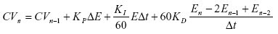
In this form of the algorithm, each term of the algorithm (proportional, integral, and derivative) has a separate gain. Changing one gain only affects that term and not any of the others, where:
PIDE term: | Description:
CV | Control variable
E | Error in percent of span
Dt | Update time in seconds used by the loop
Kp | Proportional gain
KI | Integral gain in min -1 a larger value of KI  causes a faster integral response.
KD | Derivative gain in minutes

Dependent Gains Form:
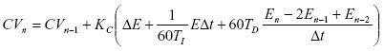
This form of the algorithm changes the proportional gain into a controller gain. By changing the controller gain, you change the action of all three terms (proportional, integral, and derivative) at the same time, where:
PIDE term: | Description:
CV | Control variable
E | Error in percent of span
Dt | Update time in seconds used by the loop
Kc | Controller gain
TI | Integral time constant in minutes per repeat a larger value of T1  causes a slower integral response It takes T1 minutes for the  integral term to repeat the action of the proportional term in  response to a step change in error.
TD | Derivative time in constant in minutes

PIDE term: | Description:
CV | Control variable
E | Error in percent of span
Dt | Update time in seconds used by the loop
Kp | Proportional gain
KI | Integral gain in min -1 a larger value of KI  causes a faster integral response.
KD | Derivative gain in minutes

Determining Which Algorithm to Use:
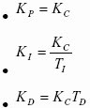

The PIDE equations above are representative of the algorithms used by the PIDE instruction. You can substitute the change in error values for the change in PV (in percent of span) for the proportional and derivative terms by manipulating the parameters PVEProportional and PVEDerivative. By default, the PIDE instruction uses the change in error for the proportional term and the change in PV for the derivative term. This eliminates large derivative spikes on changes in setpoint.
You can convert the gains used between the different PIDE algorithm forms using these equations:

Condition/State | Action Taken
Prescan | EnableIn and EnableOut bits are cleared to false.
Tag.EnableIn is false | EnableIn and EnableOut bits are cleared to false.
Tag.EnableIn is true | EnableIn and EnableOut bits are set to true.  The instruction executes.
Instruction first run | N/A
Instruction first scan | If CVFault and CVEUSpanlnv are set,see Processing Faults later  in this instruction. If CVFault and CVEUSpanlnv are cleared:  - CVInitializing is set  - If PVFault is set, PVSpanlnv and SPlimitsInv are cleared.  See Processing Faults in this instruction.  - The PID control algorithm is not executed.  - The instruction sets CVEU = CVInitValue and CV =  corresponding percentage.  - When CVInitializing and Manual AfterInit are set, the  Instructions didables auto and cascade/ratio modes.  If the current mode is not Override or Hand mode, the  instruction changes to manual ode.If ManualAfterInit is cleared, the mode is not changed.  CVEu = CVInitValue  CV  n-1  = CV = CVEU - CVEUMin x100  CVEUMax - CVEUMin  CVOper = CV
Postscan | EnableIn and EnableOut bits are cleared to false.
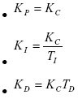

Each algorithm provides identical control with the appropriate gains. Some people prefer the independent gains style because they can manipulate individual gains without affecting the other terms. Others prefer the dependent gains style because they can, at least to a certain extent, change just the controller gain and cause an overall change in the aggressiveness of the PID loop without changing each gain separately.

Monitoring the PIDE Instruction: There is an operator faceplate available for the PIDE instruction.
Autotuning the PIDE Instruction:
The Logix Designer application PIDE autotuner provides an open-loop autotuner built into the PIDE instruction. You can autotune from PanelView terminal or any other operator interface devices, as well as the Logix Designer application. The PIDE block has an Autotune Tag (type PIDE_AUTOTUNE) that you specify for those PIDE blocks that you want to autotune.
The PIDE autotuner is installed with the application, but you need an activation key to enable it. The autotuner is only supported in function block programming; it is not available in ladder diagram or structured text programming.Use the Autotune tab to specify and configure the autotune tag for a PIDE block.
Affects Math Status Flags: No
Major/Minor : None specific to this instruction.

Execution: Function Block
Structured Text

Condition/State | Action Taken
Prescan | See Prescan in the Function Block table.
Normal Execution | See Tag.EnableIn is true in the Function  Block table.
Postscan | See Postscan in the Function Block table.
When CVInitReq is set, or during instruction first scan, or on a set to cleared transition of CVFault (bad to good), the instruction initializes the CVEU and CV outputs to the value of CVInitValue. If the timing mode is not oversample and EnableIn transitions from cleared to set, the instruction initializes the CVEU and CV values. CVInitialization is cleared after the initialization and when CVInitReq is cleared.
The CVInitValue normally comes from the analog output’s readback value. The CVInitReq value normally comes from the "In Hold" status bit on the analog output controlled by CVEU. The initialization procedure is performed to avoid a bump at startup in the output signal being sent to the field device.
When using cascaded PID loops, the primary PID loop can be initialized when the secondary loop is initialized or when the secondary loop leaves the Cascade/Ratio mode. In this case, move the state of the InitPrimary output and SP output from the secondary loop to the CVInitReq input and CVInitValue input on the primary loop.
The instruction does not initialize and the CVEU and CV values are not updated if CVFault or CVEUSpanInv is set.
Examples
Example 1
The easiest way to implement a PIDE instruction is to create a function block routine in a program in a periodic task. The default timing mode for the PIDE instruction is periodic. When the PIDE instruction is used in a periodic task and in periodic timing mode, it automatically uses the periodic task's update rate as its delta t update time. All you need to do is wire the process variable analog input into the PV parameter on the PIDE instruction and wire the CVEU out of the PIDE instruction into the controlled variable analog output.
Optionally, you can wire the analog input’s fault indicator (if one is available) into the PVFault parameter on the PIDE instruction. This forces the PIDE into Manual mode when the analog input is faulted and stops the PIDE CVEU output from winding up or down when the PV signal is not available.
Function Block
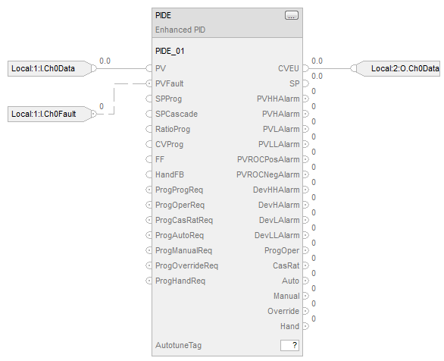
Structured Text
PIDE_01.PV := Local:1:I.Ch0Data;
PIDE_01.PVFault := Local:1:I.Ch0Fault;
PIDE(PIDE_01);
Local:2:)O.Ch0Data :=PIDE_01.CVEU;

Example 2:
Cascade control is useful when externally-caused upsets to the controlled variable occur often, which then cause upsets to the process variable you are trying to control. For example, try to control the temperature of liquid in a tank by varying the amount of steam fed into a heating jacket around the tank. If the steam flow suddenly drops because of an upstream process, the temperature of the liquid in the tank eventually drops and the PIDE instruction then opens the steam valve to compensate for the drop in temperature. In this example, a cascaded loop provides better control by opening the steam valve when the steam flow drops before the liquid temperature in the tank drops. To implement a cascaded loop, use a PIDE instruction to control the steam valve opening based on a process variable signal from a steam flow transmitter. This is the secondary loop of the cascaded pair. A second PIDE instruction (called the primary loop) uses the liquid temperature as a process variable and sends its CV output into the setpoint of the secondary loop. In this manner, the primary temperature loop asks for a certain amount of steam flow from the secondary steam flow loop. The steam flow loop is then responsible for providing the amount of steam requested by the temperature loop in order to maintain a constant liquid temperature.

Cascaded Function Blocks:
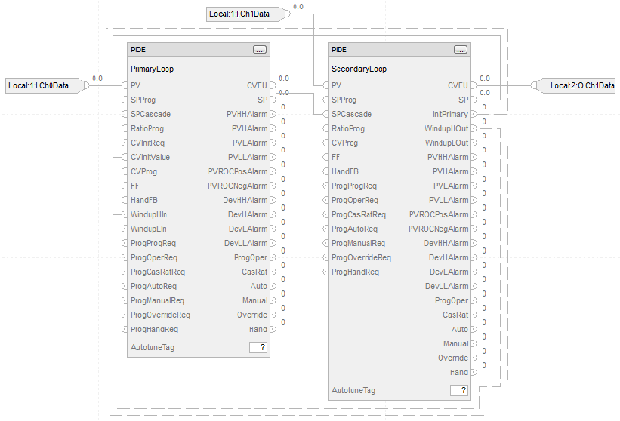
Structured Text:
PIDE(PrimaryLoop):
PrimaryLoop.PV := Local:1:I.CH0Data;
PrimaryLoop.CVInitReq := SecondaryLoop.InitPrimary;
PrimaryLoop.CVInitValue := SecondaryLoop.SP;
PrimaryLoop.WindupHIn := SecondaryLoop.WindupHOut;
PrimaryLoop.WindupLIn := SecondaryLoop.WindupLOut;
PIDE(SecondaryLoop):
SecondaryLoop.PV := Local:1:I.Ch1Data;
SecondaryLoop.SPCascade := PrimaryLoop.CVEU;
Local:2:O.Ch0Data:= SecondaryLoop.CVEU;
For a cascaded pair of loops to work correctly, the secondary loop must have a faster process response than the primary loop. This is because the secondary loop’s process must be able to compensate for any upsets before these upsets affect the primary loop’s process. In this example, if steam flow drops, the steam flow must be able to increase as a result of the secondary controller’s action before the liquid temperature is affected.
How to set up a pair of cascaded PIDE instructions:

1). Set the AllowCasRat = 1 input parameter in the secondary loop. This allows the secondary loop to be placed into Cascade/Ratio mode.

2). Wire the CVEU from the primary loop into the SPCascade parameter on the
secondary loop.
a). The SPCascade value is used as the SP on the secondary loop when
the secondary loop is placed into Cascade/Ratio mode.

3). Set engineering unit range of the CVEU on the primary loop to the
engineering unit range of the PV on the secondary loop.
a). This lets the primary loop scale its 0-100% value of CV into the
matching engineering units used for the setpoint on the secondary loop.

NOTE: The PIDE instruction supports several other features to more effectively support cascade control.
4). Wire the InitPrimary output on the secondary loop into the CVInitReq
input on the primary loop.

5). Wire the SP output of the secondary into the CVInitValue input on the primary.
a). This sets the CVEU value of the primary loop equal to the SP of the
secondary loop when the secondary loop leaves Cascade/Ratio mode.
b). Allowing a bumpless transfer when you place the secondary loop back
into Cascade/Ratio mode.

6). Wire the WindupHOut and WindupLOut outputs on the secondary loop into
The WindupHIn and WindupLIn inputs on the primary loop.
a). This causes the primary loop to stop increasing or decreasing, as
appropriate, its value of CVEU if the secondary loop hits a SP limit or CV
limit and eliminates any windup on the primary loop if these conditions
occur.

Example 3:
Ratio control is typically used to add a fluid in a set proportion to another fluid. For example, if you want to add two reactants (say A and B) to a tank in a constant ratio, and the flow rate of reactant A may change over time because of some upstream process upsets, you can use a ratio controller to automatically adjust the rate of reactant B addition. In this example, reactant A is often called the "uncontrolled" flow since it is not controlled by the PIDE instruction. Reactant B is then called the "controlled" flow.
To perform ratio control with a PIDE instruction:
1). Set the AllowCasRat and UseRatio input parameters.

2). Wire the uncontrolled flow into the SPCascade input parameter.
a). When in Cascade/Ratio mode, the uncontrolled flow is multiplied by
either the RatioOper (when in Operator control) or the RatioProg (when in
Program control).
b). The resulting value is used by the PIDE instruction as the setpoint.

Function Block:
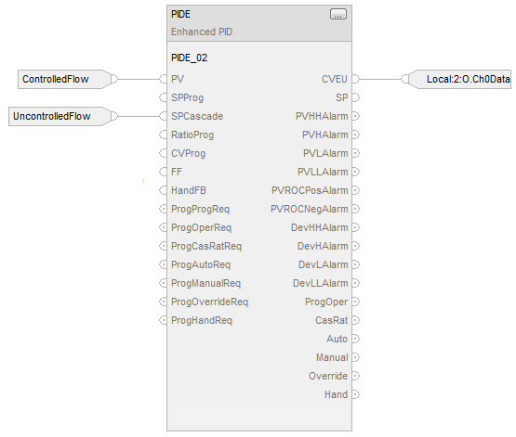
Structured Text
PIDE_01.PV := ControlledFlow;
PIDE_01.SPCascade := UncontrolledFlow;
PIDE(PIDE_01);
Local:2:O.Ch0Data := PIDE_01.CVEU;
Switching Between Program Control and Operator Control
The PIDE instruction can be controlled by either a user program or an operator interface. You can change the control mode at any time. Program and Operator control use the same ProgOper output. When ProgOper is set, control is Program; when ProgOper is cleared, control is Operator.
The following diagram shows how the PIDE instruction changes between Program control and Operator control.
PID Operating Mode | Description
Cascade/Ratio | While in Cascade/Ratio mode the instruction computes the change in CV. The instruction  regulates CV to maintain PV at either the SPCascade value or the SPCascade value  multiplied by the Ratio value. SPCascade comes from either the CVEU of a primary PID  loop for cascade control or from the "uncontrolled" flow of a ratio-controlled loop.  Select Cascade/Ratio mode using either OperCasRatReq or ProgCasRatReq:  Set OperCasRatReq to request Cascade/Ratio mode. Ignored when ProgOper,  ProgOverrideReq, ProgHandReq, OperAutoReq, or OperManualReq is set, or when  AllowCasRat is cleared.  Set ProgCasRatReq to request Cascade/Ratio mode. Ignored when ProgOper or  AllowCasRat is cleared or when ProgOverrideReq, ProgHandReq, ProgAutoReq, or  ProgManualReq is set.
Auto | While in Auto mode the instruction computes the change in CV. The instruction regulates  CV to maintain PV at the SP value. If in program control, SP = SPProg; if in Operator  control, SP = SPOper.  Select Auto mode using either OperAutoReq or ProgAutoReq:  Set OperAutoReq to request Auto mode. Ignored when ProgOper, ProgOverrideReq,  ProgHandReq, or OperManualReq is set.  Set ProgAutoReq to request Auto mode.  Ignored when ProgOper is cleared or when ProgOverrideReq, ProgHandReq, or  ProgManualReq is set.
Manual | While in Manual mode the instruction does not compute the change in CV. The value of  CV is determined by the control. If in Program control, CV = CVProg; if in Operator control,  CV = CVOper.  Select Manual mode using either OperManualReq or ProgManualReq:  Set OperManualReq to request Manual mode. Ignored when ProgOper, ProgOverrideReq,  or ProgHandReq is set.  Set ProgManualReq to request Manual mode. Ignored when ProgOper is cleared or when  ProgOverrideReq or ProgHandReq is set.
Override | While in Override mode the instruction does not compute the change in CV.  CV = CVOverride, regardless of the control mode. Override mode is typically used to  set a "safe state" for the PID loop.  Select Override mode using ProgOverrideReq:  Set ProgOverrideReq to request Override mode. Ignored when ProgHandReq is cleared.
Hand | While in Hand mode the PID algorithm does not compute the change in CV.  CV = HandFB, regardless of the control mode. Hand mode is typically used to indicate  that control of the final control element was taken over by a field hand/auto station.  Select Hand mode using ProgHandReq:  Set ProgHandReq to request hand mode. This value is usually read as a digital input from a hand/auto station.
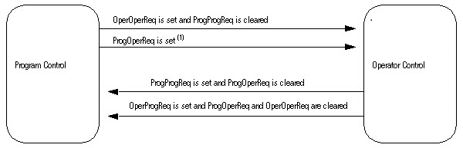

(1) The instruction remains in Operator control mode when ProgOperReq is set.
Operating Modes
The PIDE instruction supports the following PID modes.
Cascade/Ratio
Auto
Manual
Modes can be controlled by a user program when in Program control or by an operator interface when in Operator control. The Override and Hand modes have a mode request input that can only be controlled by a user program; these inputs operate in both Program and Operator control.
Selecting the Setpoint:
Once the instruction determines program or operator control and the PID mode, the instruction can obtain the proper SP value. You can select the cascade/ratio SP or the current SP.
Cascade/Ratio SP:
The cascade/ratio SP is based on the UseRatio and ProgOper values.
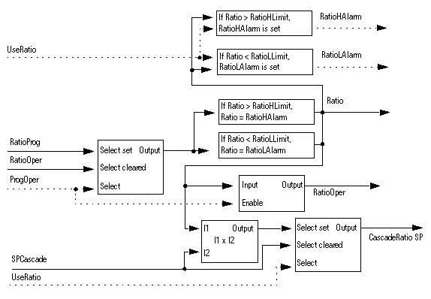
Current SP:
The current SP is based on the Cascade/Ratio mode, the PVTracking value, auto mode, and the ProgOper value.
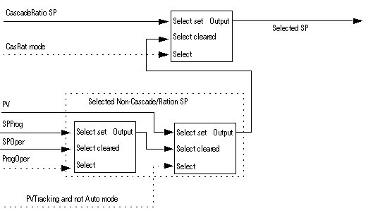

SP High/Low Limiting:
The high-to-low alarming algorithm compares SP to the SPHLimit and SPLLimit alarm limits. SPHLimit cannot be greater than PVEUMax and SPLLimit cannot be less than PVEUMin.
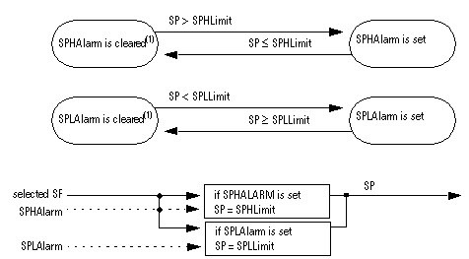
Updating the SPOper and SPProg Values:
The PIDE instruction makes SPOper = SP or SPProg = SP to obtain bumpless control switching between Program and Operator control or when switching from Cascade/Ratio mode.
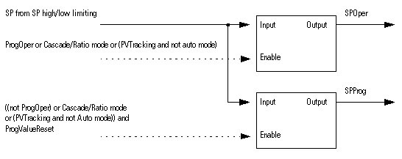
PV High/Low Alarming:
The high-high to low-low alarming algorithm compares PV to the PV alarm limits and the PV alarm limits plus or minus the PV alarm deadband
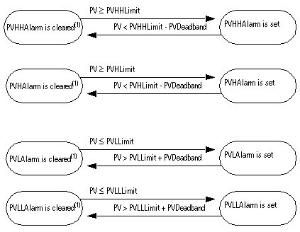
(1) During instruction first scan, the instruction clears all the PV alarm outputs. The instruction also clears the PV alarm outputs and disables the alarming algorithm when PVFaulted is set.

PV Rate-of-Change Alarming:
PV rate-of-change (ROC) alarming compares the change in the value of PV over the PVROCPeriod against the PV positive and negative rate-of-change limits. The PVROCPeriod provides a type of deadband for the rate-of-change alarm. For example, if you use a ROC alarm limit of 2°F/second with a period of execution of 100 ms, and an analog input module with a resolution of 1°F, then every time the input value changes, a ROC alarm is generated because the instruction sees a rate of 10°F/second. However, by entering a PVROCPeriod of at least 1 sec, the ROC alarm is only generated if the rate truly exceeds the 2°F/second limit.
The ROC calculation is only performed when the PVROCPeriod has expired.
The rate-of-change is calculated as:
ElapsedROCPeriod = ElapsedROCPeriod + ElapsedTimeSinceLastExecution
If ElapsedROCPeriod > PVROCPeriod then:
This value: | Is:
PVROC | 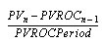
PVROC N-1 | PVROC N-1 = PV
ElapsedROCPeriod | ElapsedROCPeriod = 0

Once PVROC has been calculated, the PV ROC alarms are determined as follows:
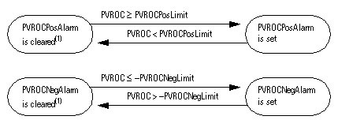
(1) During instruction first scan, the instruction clears the PV ROC alarm outputs. The instruction also clears the PVROC alarm outputs and disables the PV ROC alarming algorithm when PVFaulted is set.

Converting the PV and SP Values to Percent:
The instruction converts PV and SP to a percent and calculates the error before performing the PID control algorithm. The error is the difference between the PV and SP values. When ControlAction is set, the values of EPercent, E, and PVPIDPercent are negated before being used by the PID algorithm.
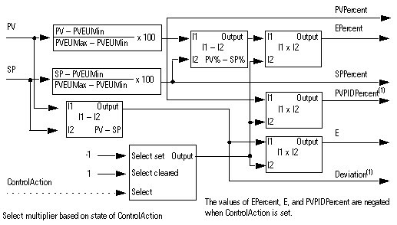
(1) PVPIDPercent and Deviation are internal parameters used by the PID control algorithm.

Deviation High/Low Alarming:
Deviation is the difference in value between the process variable (PV) and setpoint (SP). Deviation alarming alerts the operator to a discrepancy between the process variable and the setpoint value.
The high-high to low-low alarming algorithm compares the deviation to deviation alarm limits and the deviation alarm limits plus or minus the deadband.
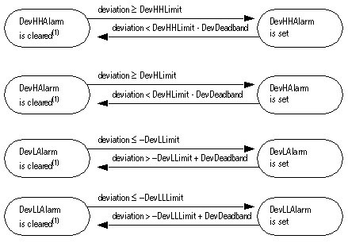
(1) During instruction first scan, the instruction clears the deviation alarm outputs. The instruction also clears the deviation alarm outputs and disables the alarming algorithm when PVFaulted or PVSpanInv is set.

Zero Crossing Deadband Control:
You can limit CV such that its value does not change when error remains within the range specified by ZCDeadband (| E | £ ZCDeadband).

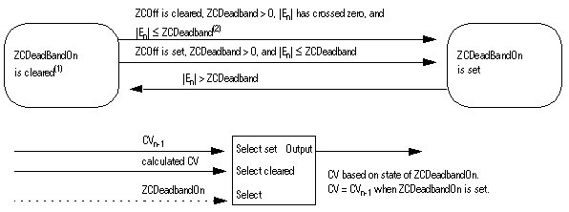
(1)
When ZCOff is cleared, ZCDeadband > 0, error has crossed zero for the first time, (i.e. En >= 0 and En-1 < 0 or when En <= 0 and En-1 > 0), and | En | <= ZCDeadband, the instruction sets ZCDeadbandOn.

(2) On the transition to Auto or Cascade/Ratio mode, the instruction sets En-1 = En.
The instruction disables the zero crossing algorithm and clears ZCDeadband under these conditions:
- during instruction first scan
- ZCDeadband £ 0

- Auto or Cascade/Ratio is not the current mode
- PVFaulted is set
- PVSpanInv is set

Feedforward Control:
Compute CV by summing CV from the zero crossing algorithm with ∆FF. The value of ∆FF = FF – FFn-1.
When FFSetPrevious is set, FFn-1=FFPrevious. This lets you preset FFn-1 to a specified value before the instruction calculates the value of ∆FF.

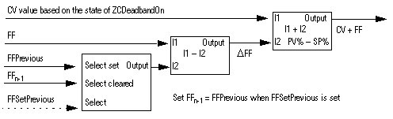

Selecting the Control Variable:
Once the PID algorithm has been executed, select the CV based on program or operator control and the current PID mode.
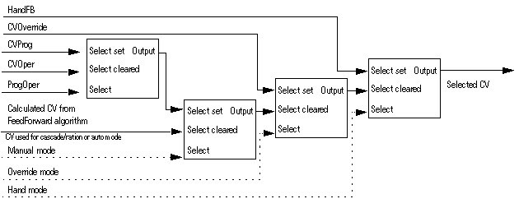

CV Windup Limiting:
Limit the CV such that its value cannot increase when WindupHIn is set or decrease when WindupLIn is set. These inputs are typically the WindupHOut or WindupLOut outputs from a secondary loop. The WindupHIn and WindupLIn inputs are ignored if CVInitializing, CVFault, or CVEUSpanInv is set.
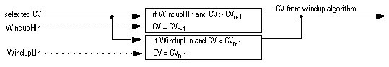

CV Percent Limiting:
The following diagram illustrates how the instruction determines CV percent limiting.
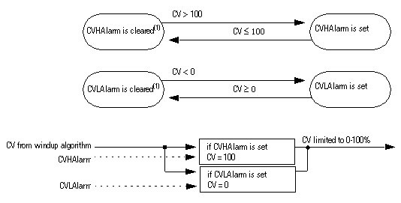
(1) During instruction first scan, the instruction clears the alarm outputs.

CV High/Low Limiting:
The instruction always performs alarming based on CVHLimit and CVLLimit. Limit CV by CVHLimit and CVLLimit when in auto or cascade/ratio mode. When in manual mode, limit CV by CVHLimit and CVLLimit when CVManLimiting is set. Otherwise limit CV by 0 and 100 percent.
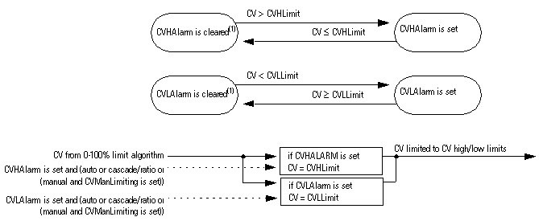
(1) During instruction first scan, the instruction clears the alarm outputs.

CV Rate-of-Change Limiting:
The PIDE instruction limits the rate-of-change of CV when in Auto or Cascade/Ratio mode or when in Manual mode and CVManLimiting is set. A value of zero disables CV rate-of-change limiting.
The CV rate-of-change is calculated as:
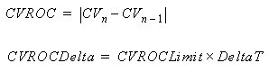
where DeltaT is in seconds.
Once CV rate-of-change has been calculated, the CV rate-of-change alarms are determined as follows:
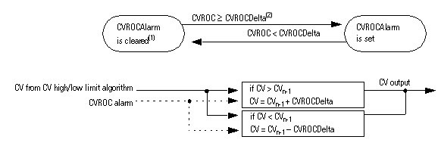
(1) During instruction first scan, the instruction clears the alarm output. The instruction also clears the alarm output and disables the CV rate-of-change algorithm when CVInitializing is set.
(2) When in Auto or Cascade/Ratio mode or when in Manual mode and CVManLimiting is set, the instruction limits the change of CV.

Updating the CVOper and CVProg Values:
If not in the Operator Manual mode, the PIDE instruction sets CVOper = CV. This obtains bumpless mode switching from any control to the Operator Manual mode.
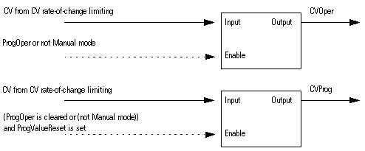
Primary Loop Control:
Primary loop control is typically used by a primary PID loop to obtain bumpless switching and anti-reset windup when using Cascade/Ratio mode. The primary loop control includes the initialize primary loop output and the anti-reset windup outputs. The InitPrimary output is typically used by the CVInitReq input of a primary PID loop. The windup outputs are typically used by the windup inputs of a primary loop to limit the windup of its CV output.
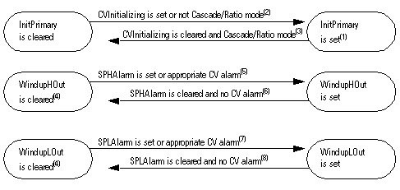
(1) During instruction first scan, the instruction sets InitPrimary.
(2) When CVInitializing is set or when not in Cascade/Ratio mode the instruction sets InitPrimary.
(3) When CVInitializing is cleared and in Cascade/Ratio mode, the instruction clears InitPrimary.
(4) During instruction first scan, the instruction clears the windup outputs. The instruction also clears the windup outputs and disables the CV windup algorithm when CVInitializing is set or if either CVFaulted or CVEUSpanInv is set.
(5) The instruction sets WindupHOut when SPHAlarm is set, or when ControlAction is cleared and CVHAlarm is set, or when ControlAction is set and CVLAlarm is set.
The SP and CV limits operate independently. A SP high limit does not prevent CV from increasing in value. Likewise, a CV high or low limit does not prevent SP from increasing in value.
(6) The instruction clears WindupHOut when SPHAlarm is cleared, and not (ControlAction is cleared and CVHAlarm is set), and not (ControlAction is set and CVLAlarm is set).
(7) The instruction sets WindupLOut when SPLAlarm is set, or when ControlAction is cleared and CVLAlarm is set, or when ControlAction is set and CVHAlarm is set.
a). The SP and CV limits operate independently. A SP low limit does not prevent
CV from increasing in value. likewise a CV low or high limit does not prevent SP
(8) The instruction clears WindupLOut when SPLAlarm is cleared and not (ControlAction is cleared and CVLAlarm is set) and not (ControlAction is set and CVHAlarm is set).

Processing Faults:
The following table describes how the instruction handles execution faults:

Fault Condition | Action
CVFaulted is true or  CVEUSpanInv is true | Instruction is not initialized, CVInitializing is cleared to false  Compute PV and SP percent, calculate error, update internal parameters for  EPercent and PVPIDPercent  PID control algorithm is not executed  Disable the Auto and Cascade/Ratio modes.  If Override or Hand is not the current mode, set to Manual mode.  Set CV to value determined by Program or Operator control and mode  (Manual, Override, or Hand).
PVFaulted is true | Disable the Auto and Cascade/Ratio modes. If Override or Hand is not the  current mode, set to Manual mode PV high-low, PV rate-of-change, and  deviation high-low alarm outputs are cleared to false PID control algorithm  is not executed  Set CV to value determined by Program or Operator control and mode  (Manual, Override, or Hand).
PVSpanInv is true or  SPLimitsInv is true | Disable the Auto and Cascade/Ratio modes. If Override or Hand is not the  current mode, set to Manual mode  Do not compute PV and SP percent  PID control algorithm is not executed  Set CV to value by determined by Program or Operator control and mode  (Manual, Override, or Hand).
RatioLimitsInv is true and  CasRat is true and  UseRatio is true | If not already in Hand or Override, set to Manual model  Disable the Cascade/Ratio mode  Set CV to value determined by Program or Operator control and mode  (Manual, Override, or Hand).
TimingModeInv is true or  RTSTimeStampInv is true or  DeltaTInv is true | If not already in Hand or Override, set to Manual mode

